**Dear Exhibitor,**

**Thank you SO VERY MUCH for registering for a Trade Show booth at the CCUFSA Conference!**

We are grateful to all our vendors for booking a booth to support CCUFSA during this very busy time. We look forward to a continued healthy and prosperous business relationship with all of you!

**READ THE BELOW COMPLETELY & CAREFULLY**

**All shipments to the trade show must be co-ordinated with Sue Heath at Caesars Windsor. (contact # is below)**

**You may begin set up your trade show booth, any time AFTER 12 NOON on Wednesday, June 22nd, or beginning at 7:30 am on June 23rd in Augustus II & III (trade show starts at 12:00 noon SHARP on the 23rd)**

The number of trade show vendors has been scaled back, your booth is now 10’ x 10’ and will include black pipe and drape, two 6' skirted tables and 1 chair (as needed) and 1 (one) standard electrical outlet plus the other indications you made on your reg form. **All other furnishings, electrical cables, equipment etc.** **required are the responsibility of the exhibitor at their own expense. CCUFSA does not stock extra electrical equipment on site.**

2022 TRADE SHOW

**Exhibitor Package and Shipping Details**

**Updated May 27, 4:00 pm**

CCUFSA will pay on-site kitchen, cooking and standard electrical expenses. **Craig Clifford from Western University** will be our CCUFSA liaison in the kitchen for all cooking needs of your foods in the Casino kitchen and expediting cooked food to your booth. **Mark Kenny** will be on the trade show floor. **My cell number is 519-400-2048**.

Any special electrical requirements will be billed directly or back to the exhibitor at cost.

*There is NO COOKING with OPEN FLAME permitted at any time, on the trade show floor.  
  
\*\*\** PERMITTED TO COOK *with at the trade show:* Induction portable cooktop burners, flat top griddles or similar, insta pot, heat lamp.

*** NOT PERMITTED TO COOD WITH Cookie Oven, air fryer, deep fryer - all other equipment to be approved by CCUFSA**

**\* CCUFSA will supply hand washing stations at booths as required by health board \***

Trade Show booth guidelines / rules and regulations are attached for you reference.

**VENDORS MUST PROTECT TRADE SHOW CARPETED FLOOR FROM ANY DAMAGE AT ALL TIMES**

Tear down of booths can begin be **after the CCUFSA Raffle Prizes** at 4:00 pm.

After the trade show, all waste materials are to be placed in garbage bags inside at the large waste containers provided.

All cardboard boxes are to be broken down and placed in front of the booth.

Exhibitors displaying heavy equipment (i.e. fridges, dishwashers, foodservice equipment, etc.) must provide pads underneath the equipment. Exhibitors will be responsible for any repairs, replacements or extraordinary cleaning as a result of their use of the function areas in Trade Show space.

Non-perishable foods leftover may be donated to the local food bank, there will be a designated area on the trade show floor for these.

**ELECTRICAL SERVICES**

**It is the vendors responsibility to ensure all your electrical equipment, cords, connections are in safe working order.**

Any vendor requiring special power is to reach out directly to Sue Heath no later than June 8th to arrange their power. THE SOONER THE BETTER.

**LOADING DOCK will be Augustus #5 (Images Below)**

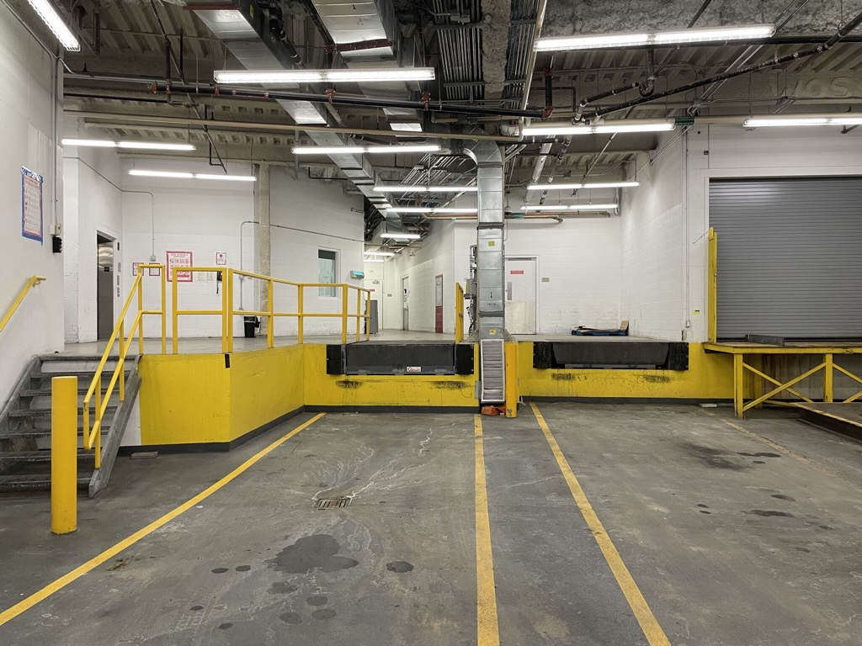

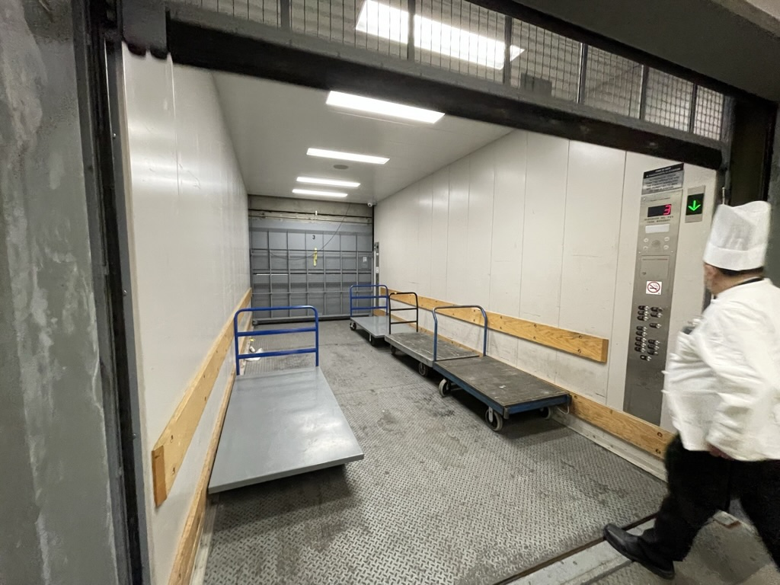**Trade Show Elevator**

**MATERIAL HANDLING INFORMATION**

Any questions regarding shipping / receiving to or from the show must be directed to **Sue Heath**.

**ON SITE MATERIAL HANDLING INFORMATION**Caesars Windsor is pleased to offer Material Handling Services for your event. Services provided by a third party.

**MATERIAL HANDLING SERVICE INCLUDES:**

* Unloading of shipment from your vehicle at **Augustus Loading Dock # 5** & delivery directly to your Trade Show booth.  
  + **ALL ITEMS TO BE USED AT YOUR BOOTH MUST BE DELIVERED TO THE LOADING DOCK. THE CASINO DOES NOT PERMIT VENDORS TO WALK THROUGH THE CASINO OR HOTEL WITH TRADE SHOW BOOTH SETUPS, DISPLAYS, BANNERS, TABLING, EQUIPMENT, BOXES OF PRODUCT ETC.**
  + **Only that which you can carry in your hands is permitted to travel with you in the hotel.**
* Loading of shipment from booth to carrier of choice or your vehicle.

**Note: Transportation to and from show site is not included as part of this service.**

**OTHER IMPORTANT INFORMATION:**

* Arrangements for material handling services is to be set up ASAP in advance of load-in.
* This service includes move-in and move-out, whether fully or partially used.
* Number of handlers will be dependant upon number of booths, skids, etc
* **Please let SUE HEATH know if special equipment is required to move your shipment. i.e. pump jack for skids, vehicle.**
* Freight elevator specifications: **10’ x 8’ x 22’ with weight load capacity, 11,000 lbs**.
* We offer parking for over sized vehicles. Please email or call convention services for arrangements.
* All goods should be insured by your own insurance policy.

**PREPARATIONS PRIOR TO THE TRADE SHOW:**

**ALL SHIPMENTS TO THE TRADE SHOW MUST BE CO-ORDINATED WITH SUE HEATH at Caesars Windsor, AND MUST BE SCHEDULED.**  
 **SHIPPING (INBOUND EQUIPMENT) *PRIOR* TO TRADE SHOW (Dock 5)**

*To ship equipment, trade show booth displays, small wares, large item prior to the conference,* ***vendors MUST email or call to arrange directly with:***

**Sue Heath, Convention Services Manager**

[heath@caesarswindsor.com](mailto:heath@caesarswindsor.com)

(519) 985-2822

WE ASK DRIVERS TO KEEP TO A STRICT 5 MINUTES AT THE LOADING DOCK FOR UNLOADING, AS WE HAVE MANY VENDORS TO LOAD PRODUCT INTO THE SHOW.

**SHIPPING (INBOUND) DATES & TIMES ARE AS FOLLOWS  
(equipment/displays):**

|  |  |  |  |
| --- | --- | --- | --- |
| **Thursday, June 16th** | **Friday, June 17th** | **Monday, June 20th** | **Tuesday, June 21st** |
| 8 am - 4 pm | 8 am - 4 pm | 8 am - 4 pm | 8 am - 4 pm |

**LOAD-IN (PRODUCTS) FOR TRADE SHOW ONLY (DOCK 5)**

**Load in is for product for booths (food, brochures, on table displays etc.)**

|  |  |
| --- | --- |
| **Wednesday, June 22nd** | **Thursday, June 23rd** |
| 12 pm - 4 pm | 7 am - 11 am |

Shipments MUST BE ADDRESSED TO:

**Caesars Windsor, Dock # 5**

Attention – **Sue Heath**, Convention Services Manager

377 Riverside Dr. East

**Windsor, Ontario**

**N9A 7H7**

**AFTER THE TRADE SHOW:**

**LOAD-OUT FOR TRADE SHOW ONLY (DOCK 5)**

After the trade show, place all goods you wish to take with you, (to be moved to loading dock), at your booth on carts provided. Material Handling staff will take to the loading dock #5, you can pick up with you own vehicle immediate following the show. **\*\* You cannot take product on carts through the hotel, everything must go through the loading dock \*\*\***

**SHIPPING (OUTBOUND) *POST* TRADE SHOW (Dock 5)**

To ship equipment, trade show booth displays, small wares, large item after the conference, **vendors MUST email or call to arrange directly with:**

**Sue Heath, Convention Services Manager**

[heath@caesarswindsor.com](mailto:heath@caesarswindsor.com)

(519) 985-2822

You must have all your shipping labels affixed to all items to be shipped out (after the trade show)

These outbound large shipments can be stored at the casino and picked-up at these times:

|  |  |
| --- | --- |
| **Friday, June 24th** | **Monday, June 27th** |
| 8 am - 4 pm | 8 am - 4 pm |

**Any questions for shipping in or out must be directed to Sue Heath.**

ON ALL INBOUND PACKAGES/ SKIDS:

**YOU MUST indicate name of event:**

**1. CCUFSA TRADE SHOW,**

**2. Your full contact name & cell phone number,**

**3. Conference dates: (JUNE 22 - 26),**

**4. Your company name and Trade Show booth # (see attached floor map),**

**5. Indicate deliver to :**

**A. Trade Show Floor**

**B. Dry Storage**

**C. Fridge**

**D. Freezer Product**

**Box___of___ (total # of boxes in shipment must be indicated)**

**Our elegant new conference spaces are open to all ages and are accessed independently and separate from our gaming environment. NO INDIVIDUAL UNDER THE AGE OF 19 WILL BE ALLOWED ACCESS TO THE GAMING AREA.**



